US ^{How To:}
UniqueSchools
Send a Notification
Notifications go to your App Notifications feed. Notifications are visible to all App users.
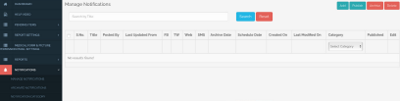
Open your App
CMS panel & click
‘Notificatons’ then
‘Manage
Notifications’
and ‘Add’
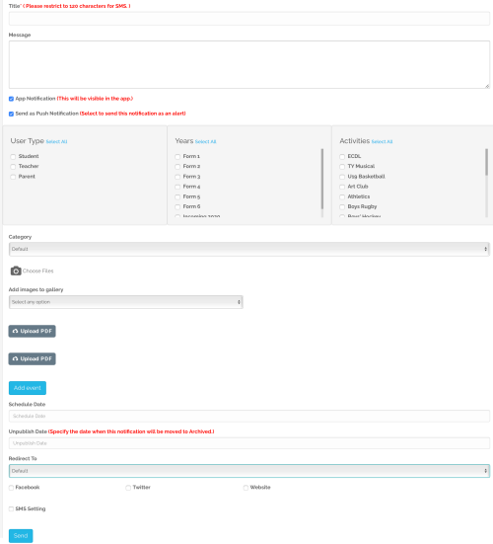
Title/heading of your notification
Content of your notification
Auto-selected to ensure your notification is displayed in the school App
Auto-selected to ensure user gets a notification/beep on their device
Select who is to receive the notification/beep on their phone; eg parents of 2nd year students. Note: only these people will get a beep on their device but notification is visible to ALL app users.
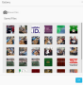
Option to tag Notification with Category if already set up under ‘Notification Category’ (under Notifications on sidedraw) Choose image from Gallery or upload new image(s) from computer
Option to add image(s) to existing album or create a new album
Click here to include a PDF in your notification
Option to add event to App Calendar
Option to schedule notification to go out at a later date/time
Set date for notification to be archived – if you don’t select a date this will auto-archive after 60 days
Include link to another App module (from dropdown list) that you would like user to go to for more information Share post to Facebook or Twitter Share to website - only available for Wordpress websites Option to send an SMS to any non-app users. Note: title of notification shows in the SMS plus link to rest of message Click ‘Send’ to post Notification

